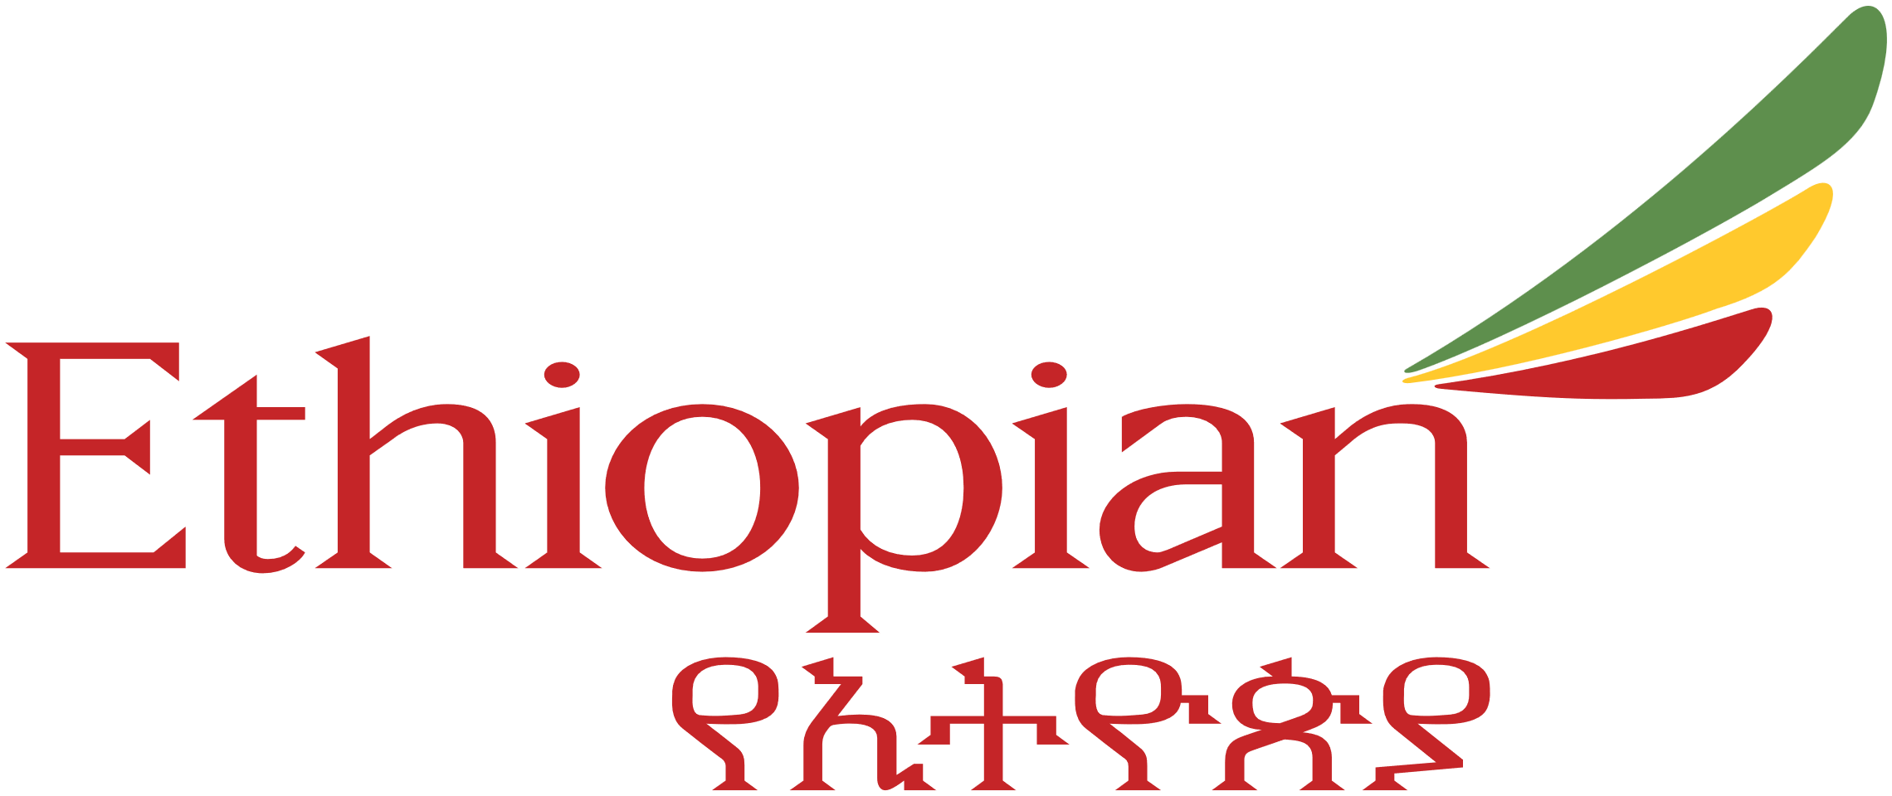

CERTIFICATE

This is to certify that Mr. SAMUEL MULUGETA has completed Industrial Training during the period from July 1 to September 30, 2024 in our Organization Ethiopian Airlines. He was trained in the field of Electromechanical Engineering.

**Signature & Seal of Training Manager**